CORPORATE OUTREACH AND LEAD GENERATION REPORT

1. EXECUTIVE SUMMARY
This report presents the corporate outreach and lead-generation activities undertaken by Epahubb under Project 50K.
The exercise focused on introducing Epahubb's software solutions to potential customers, identifying organisations with operational and technology needs, engaging business owners and institutional representatives, and identifying opportunities for demonstrations, future proposals and business partnerships.
A total of 40 organisations were contacted. Of these, 20 were physically visited, while conversations were held with representatives of the other 20 organisations.
The outreach identified opportunities in the education, hospitality, retail, beauty, healthcare and business sectors. Several organisations expressed interest in learning more about Epahubb's products, while others indicated that they were not interested at this time.
The strongest opportunities identified include schools considering Epasmart, a potential software collaboration with Frimpong Laundry, and businesses requiring further discussion about digital solutions.
Ten proposed follow-up visits have also been prepared for November 2026. These dates are proposed and require confirmation from the respective organisations.
The report concludes with a prioritised prospect list, commercial estimates based on Epahubb's current pricing, and recommendations for converting prospects into paying customers.

2. OBJECTIVES OF THE OUTREACH EXERCISE
The objectives were to:
- Introduce Epahubb and its products to potential customers.
- Identify organisations with problems that can be addressed through software solutions.
- Engage business owners, headmasters, managers and other relevant representatives.
- Identify interested prospects and potential business partnerships.
- Arrange follow-up discussions and product demonstrations.
- Identify opportunities that can advance to commercial proposals and negotiations.
- Build a pipeline of potential customers for Project 50K.

3. OUTREACH ACTIVITY SUMMARY
Activity | Result
Total organisations contacted | 40
Physical organisational visits | 20
Other organisational conversations | 20
Proposed follow-up visits | 10
Detailed engagement outcomes documented | 9
Priority commercial and partnership opportunities identified | 5
Outreach date: 6 November 2026.
The 20 physical visits involved direct engagement with organisational representatives. The remaining 20 organisations were contacted through conversations, and the user reported that they were not interested at the time of contact, subject to the individual engagement details recorded in this report.

4. COMPLETE ORGANISATION OUTREACH REGISTER
The following register documents the 40 organisations contacted during the outreach exercise.
No. | Organisation | Contact person / position | Contact number | Outreach status
1 | Maggiefrimps Company Limited | RTI Manager / IT Manager | 0244561567 | Physically visited
2 | Marthin Luther Complex | Headmaster | 0249373187 | Physically visited
3 | Peesis Services | Owner | 0530641126 | Physically visited
4 | Frimpong Laundry | Owner | 0201825393 | Physically visited
5 | Lighthouse Preparatory School | Headmaster | 0244433312 | Physically visited
6 | Billbarbs Pharmacy | Owner | 0544076390 | Physically visited
7 | Solo Barbering Shop | Owner | 0242787152 | Physically visited
8 | Ayeforo Beauty Parlour | Owner | 0596686853 | Physically visited
9 | Good Foundation International School | Headmaster | 0241383334 | Physically visited
10 | Emmanuel Presby Academy | ICT Teacher / IT Head | 0246681987 | Physically visited
11 | Tongyina Hotel | Owner | 0244233858 | Physically visited
12 | Next Level Beauty Salon | Owner | 0502896861 | Physically visited
13 | Saint Paul's International School | Headmaster | 0244673756 | Physically visited
14 | Living Foundation International School | Headmaster | 0555911201 | Physically visited
15 | Cindy Cosmetics Shop | Owner | 0247788387 | Physically visited
16 | Pharmleads Pharmacy | Owner | 0208390727 | Physically visited
17 | Amazing International School | Headmaster | 0542709266 | Physically visited
18 | Belge Hopeland Educational Complex | Headmaster | 0593564623 | Physically visited
19 | Royal Nicky's Academy | Headmaster | 0242631690 | Physically visited
20 | The PSCM Villega | Andy Aikins, CEO | 0595718540 | Contacted; not interested at the time
21 | F. Wussar-Narh Associates | Francis Wussar-Narh, Owner | 0277802913 | Contacted; not interested at the time
22 | TABS Enterprise | Edward Kofi | 0277784573 | Contacted; not interested at the time
23 | Chobolobo Enterprise Ltd. | Ms. Comfort Hartmann, Director/CEO | 051280484 | Contacted; not interested at the time
24 | Cashew Nut Export and Importation | Philip Johnson | 0247766326 | Contacted; not interested at the time
25 | Anagen Haircare | Owner | 0245182229 | Contacted; not interested at the time
26 | Auduluxe Enterprise | Owner | 0503574451 | Contacted; not interested at the time
27 | G's Sip and Bite | Owner | 0594198576 | Contacted; not interested at the time
28 | O. Ansah Company Ltd. | Joe Owusu-Ansah, Director/CEO | 0244680668 | Contacted; not interested at the time
29 | Wide Trend World Enterprise | Frimpong Frank | 0244258222 | Contacted; not interested at the time
30 | Kingnuri Carvings and Trading Enterprise | Nurideen Mohammed | 0244757710 | Contacted; not interested at the time
31 | Shaddis Company Limited | Alhaji Kabir Idri | 0244464169 | Contacted; not interested at the time
32 | Golden Bean Hotel | General Manager | 0557624645 | Contacted; not interested at the time
33 | Ridge Condos | General Manager | 0591585979 | Contacted; not interested at the time
34 | Lancaster Kumasi City | General Manager | 0308249803 | Contacted; not interested at the time
35 | Trustcare Specialist Hospital | Hospital Administrator | 0322034421 | Contacted; not interested at the time
36 | NGIS Group | Managing Director | 0322091608 | Contacted; not interested at the time
37 | Metro Health Hospital | Hospital Administrator | 0241850091 | Contacted; not interested at the time
38 | Trust Way Hospital | Hospital Administrator | 0322496639 | Contacted; not interested at the time
39 | Boyos Bite Restaurant | Owner | 0246068697 | Contacted; management discussion pending
40 | Nana Mensah's Mart | Owner | 0242767239 | Physically visited
Note: Contact details are reproduced from the supplied outreach register. The outcome column reflects the information provided about the outreach exercise. Specific engagement notes in Section 5 should be used where they provide a more detailed account than the general register status.

5.SELECTED DETAILED OUTREACH ENGAGEMENTS AND OUTCOMES
The following engagements provide details of the discussions, organisational needs, level of interest and next steps.

5.1 Lighthouse Preparatory School
Contact: Headmaster
Product introduced: Epasmart School Management System
The headmaster showed interest in learning more about Epasmart and invited Epahubb to return to the school to demonstrate the system. The representative indicated that the product could be demonstrated at a convenient time the following week.
Opportunity: School management system implementation.
Next action: Contact the headmaster to agree on a demonstration date and present the system's features and benefits.
Sales stage: Demonstration opportunity – date awaiting confirmation.

5.2 Marthin Luther Complex
Contact: Headmaster
Product introduced: Epasmart School Management System
The headmaster requested that Epahubb return to demonstrate the system and explain its importance to the school before a decision is made.
Opportunity: Potential implementation of Epasmart.
Next action: Arrange a demonstration and discuss the school's current administrative processes.
Sales stage: Demonstration opportunity – date awaiting confirmation.

5.3 Saint Paul's International School
Contact: Headmaster
Product introduced: Epasmart School Management System
The headmaster expressed interest in the system. The discussion also identified challenges relating to manual attendance and student score recording.
These operational challenges present an opportunity for Epasmart to improve the school's record management and administrative processes.
Opportunity: School management and academic records automation.
Next action: Conduct a product demonstration, assess the school's requirements and prepare a commercial proposal.
Sales stage: Interested prospect – requirements assessment and demonstration required.

5.4 Living Foundation International School
Contact: Headmaster
Product introduced: Epasmart School Management System
The school currently uses a student management system but experiences difficulties with adding parents to the system. The headmaster requested that Epahubb follow up when the next academic term begins.
Opportunity: Potential improvement or replacement of the school's existing student management solution, particularly in parent management.
Next action: Re-engage the headmaster at the beginning of the next academic term, demonstrate Epasmart's relevant capabilities and assess whether the school is willing to consider an alternative system.
Sales stage: Future opportunity – next-term follow-up.

5.5 Belge Hopeland Educational Complex
Contact: Headmaster
Product introduced: Epasmart School Management System
The headmaster indicated that the proprietor must first be consulted before the school can make a decision.
Opportunity: Potential school management system implementation.
Next action: Follow up after the headmaster has discussed the product with the proprietor. Request a meeting involving the relevant decision-maker.
Sales stage: Internal approval pending.

5.6 Frimpong Laundry
Contact: Owner
Opportunity type: Software collaboration / partnership
The owner has an IT background and develops software independently. Despite this, the owner expressed willingness to explore collaboration with Epahubb.
This presents a potential strategic partnership opportunity rather than a straightforward software sale.
Next action: Arrange a discussion to explore areas of collaboration, responsibilities, project opportunities and possible commercial arrangements.
Sales stage: Partnership discussion.

5.7 Emmanuel Presby Academy
Contact: ICT Teacher / IT representative
Product introduced: Epasmart School Management System
The headmaster was unavailable during the visit. The ICT teacher received Epahubb's contact information and indicated that he and other teachers were interested in the system. They would contact Epahubb when the headmaster returned.
Opportunity: Potential school management system implementation.
Next action: Follow up with the ICT teacher and arrange a discussion with the headmaster.
Sales stage: Initial interest – decision-maker engagement pending.

5.8 Next Level Beauty Salon
Contact: Owner
Product introduced: Business website solution
The owner received the proposal positively but was occupied and requested that the discussion continue at a later time. The potential cost of developing a website was identified as an important consideration.
Opportunity: Business website development.
Next action: Follow up with the owner, establish the required website features and present an affordable quotation.
Sales stage: Preliminary interest – pricing and requirements discussion pending.

5.9 Boyos Bite Restaurant
Contact: Assistant Manager
Product introduced: Epahubb business solutions
The assistant manager showed interest but indicated that the matter would need to be discussed with the manager before a decision could be made.
Opportunity: Potential business software or digital solution, subject to management requirements.

Next action: Arrange a meeting with the manager to establish the restaurant's needs and determine which Epahubb product would be suitable.
Sales stage: Initial interest – decision-maker approval pending.

5.10 Anagen Haircare
Contact: Owner / Brand Ambassador
Product introduced: Business website development
During the engagement, Epahubb introduced its website development services to the owner/brand ambassador. The owner asked which type of website would best suit her business. An e-commerce website was recommended because it would allow the business to showcase products and facilitate online purchases.
However, the owner expressed concern that the proposed e-commerce website was expensive. Epahubb is therefore considering an alternative portfolio website that would provide an affordable online presence for the business while showcasing its brand and products.
Opportunity: Business website development.
Next action: Follow up with the owner to discuss the portfolio website option, present its benefits and obtain her final decision.
Sales stage: Interested prospect – price-sensitive; alternative solution under consideration.

6. PRIORITY COMMERCIAL OPPORTUNITIES
The following five opportunities have been selected for priority follow-up based on the discussions and potential business needs identified.
Priority | Organisation | Opportunity | Current position
1 | Saint Paul's International School | Epasmart implementation | Headmaster interested; manual recordkeeping challenge identified
2 | Lighthouse Preparatory School | Epasmart implementation | Headmaster invited Epahubb to demonstrate
3 | Marthin Luther Complex | Epasmart implementation | Headmaster requested demonstration
4 | Living Foundation International School | Epasmart improvement/replacement opportunity | Existing system has parent-management difficulties
5 | Frimpong Laundry | Software collaboration | Owner willing to explore collaboration
These are qualified priority opportunities for further engagement, not confirmed contracts or guaranteed revenue.

6.1 Commercial pricing and estimated values
Epahubb's current pricing structure is:
Product/service | Pricing
Epasmart School Management System | GH₵5 per student per month
Custom software development | GH₵1,000–GH₵3,000 depending on complexity
E-commerce website | GH₵3,000–GH₵5,000

Potential revenue calculations
For schools considering Epasmart:
Monthly contract value = Number of students × GH₵5
Illustrative examples:
Number of students | Monthly value
100 | GH₵500
200 | GH₵1,000
300 | GH₵1,500
500 | GH₵2,500
1,000 | GH₵5,000
The actual student populations of the prospective schools have not yet been established. Therefore, their contract values will be determined after requirements assessment.
For Frimpong Laundry, the value of a possible collaboration will depend on the agreed scope, responsibilities and commercial arrangement.
For Next Level Beauty Salon, the applicable website quotation will depend on the requested features and complexity. The standard e-commerce website range should only be used if the owner requires an e-commerce website.
Important: No contract has been signed and no revenue from these opportunities is confirmed at the time of this report.

7. PROPOSED FOLLOW-UP AND DEMONSTRATION SCHEDULE
The following schedule has been prepared to guide the next stage of engagement.
No. | Organization | Proposed date | Purpose
1 | Maggiefrimps Company Limited | 9 November 2026 | Follow-up discussion
2 | Marthin Luther Complex | 10 November 2026 | Epasmart demonstration
3 | Peesis Services | 11 November 2026 | Follow-up discussion
4 | Frimpong Laundry | 12 November 2026 | Partnership discussion
5 | Lighthouse Preparatory School | 13 November 2026 | Epasmart demonstration
6 | Billbarbs Pharmacy | 14 November 2026 | Follow-up discussion
7 | Solo Barbering Shop | 16 November 2026 | Follow-up discussion
8 | Ayeforo Beauty Parlour | 17 November 2026 | Follow-up discussion
9 | Good Foundation International School | 18 November 2026 | Epasmart discussion
10 | Nana Mensah's Mart | 19 November 2026 | Follow-up discussion
Appointment status: All ten dates are proposed follow-up dates and have not yet been confirmed by the respective organizations.
The purpose of this schedule is to guide subsequent engagement and convert potential prospects into confirmed meetings, demonstrations and commercial discussions.

8. PRIORITISED FOLLOW-UP PLAN
Priority | Organization | Required action | Expected outcome
High | Saint Paul's International School | Arrange demonstration and establish student population | Prepare Epasmart proposal
High | Lighthouse Preparatory School | Confirm demonstration date and present Epasmart | Move towards requirements assessment
High | Marthin Luther Complex | Confirm demonstration date and explain system benefits | Obtain feedback and buying decision
High | Frimpong Laundry | Discuss partnership structure and possible projects | Identify collaboration opportunity
High | Living Foundation International School | Follow up at start of next term | Assess replacement opportunity
Medium | Belge Hopeland Educational Complex | Contact headmaster after proprietor consultation | Secure decision-maker discussion
Medium | Emmanuel Presby Academy | Follow up with ICT teacher and headmaster | Arrange institutional demonstration
Medium | Boyos Bite Restaurant | Contact management | Identify software requirements
Medium | Next Level Beauty Salon | Establish website requirements and budget | Submit quotation
Medium | Maggiefrimps Company Limited | Revisit previous inventory-management discussion | Establish whether there is a current opportunity

9. RECOMMENDATIONS FOR ADVANCING PROSPECTS
Management is encouraged to prioritise the following actions:
- Advance interested schools to demonstrations: Lighthouse Preparatory School, Marthin Luther Complex and Saint Paul's International School should receive priority attention because their representatives have shown interest in Epasmart.
- Prepare school-specific proposals: Following demonstrations, establish student populations, required modules, implementation requirements and the applicable monthly charges.
- Secure access to decision-makers: Follow up with Belge Hopeland Educational Complex, Emmanuel Presby Academy and Boyos Bite Restaurant to engage the individuals authorised to make purchasing decisions.
- Develop the partnership opportunity: Hold a separate discussion with Frimpong Laundry to determine whether a mutually beneficial software collaboration can be established.
- Follow up on future opportunities: Re-engage Living Foundation International School when the next academic term begins.
- Address price sensitivity: Prepare an appropriately scoped website proposal for Next Level Beauty Salon after confirming the owner's budget and requirements.
- Document all subsequent engagements: Record meeting confirmations, demonstrations, decisions, quotations and follow-up outcomes to support conversion tracking.

10. OUTREACH EVIDENCE APPENDIX

Evidence 1 – Organization 1
Organization: Emmanuel Presbyterian international school
Contact person: ICT teacher/IT head
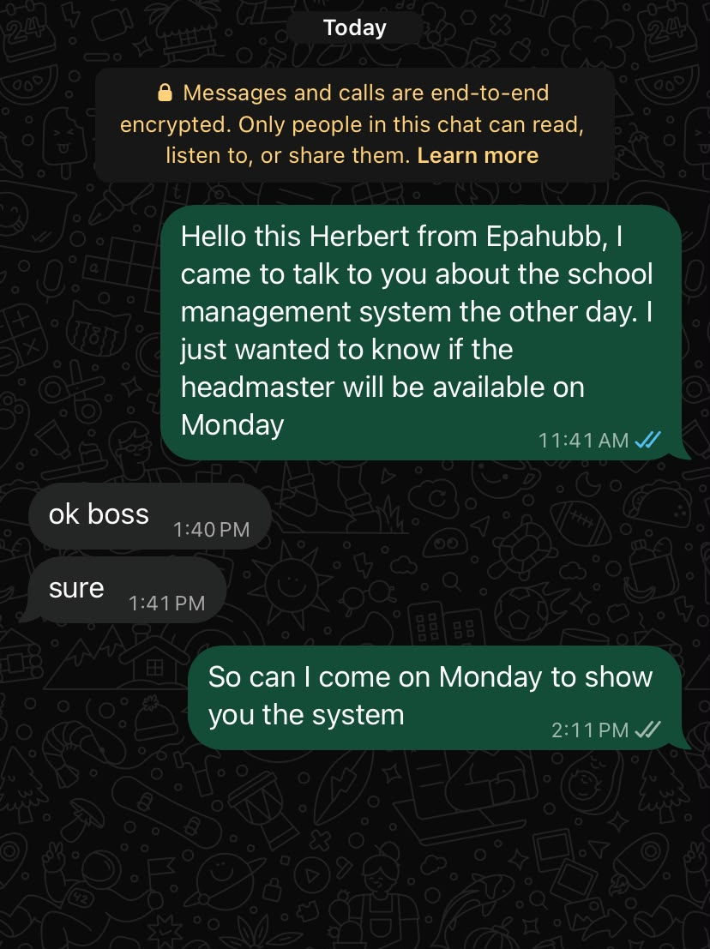

Evidence 2 – Organization 2
Organization: Frimpong Tech
Contact person: Owner
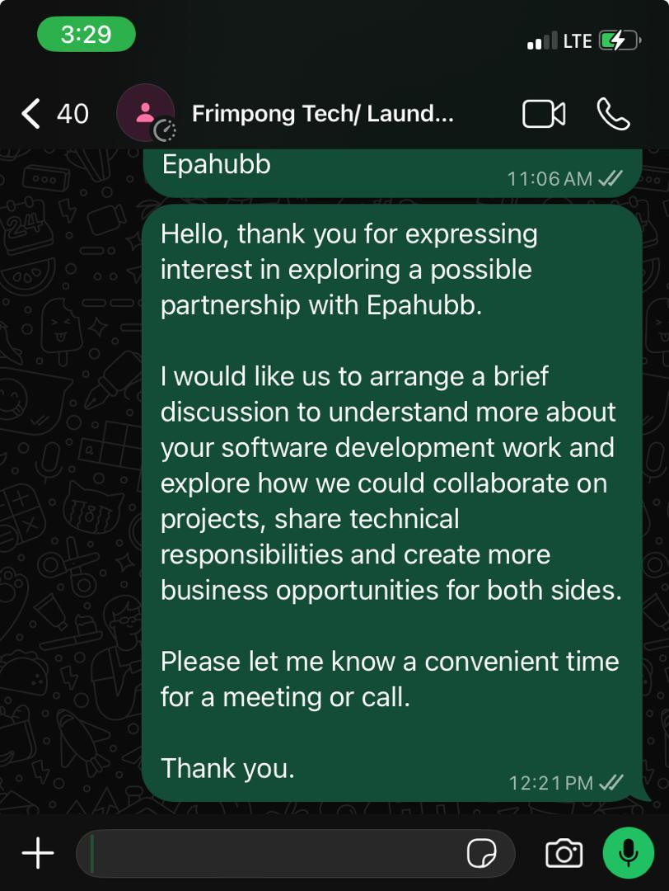

Evidence 3 – Organization 3
Organization: Nana Mensah's Mart
Contact person: Owner
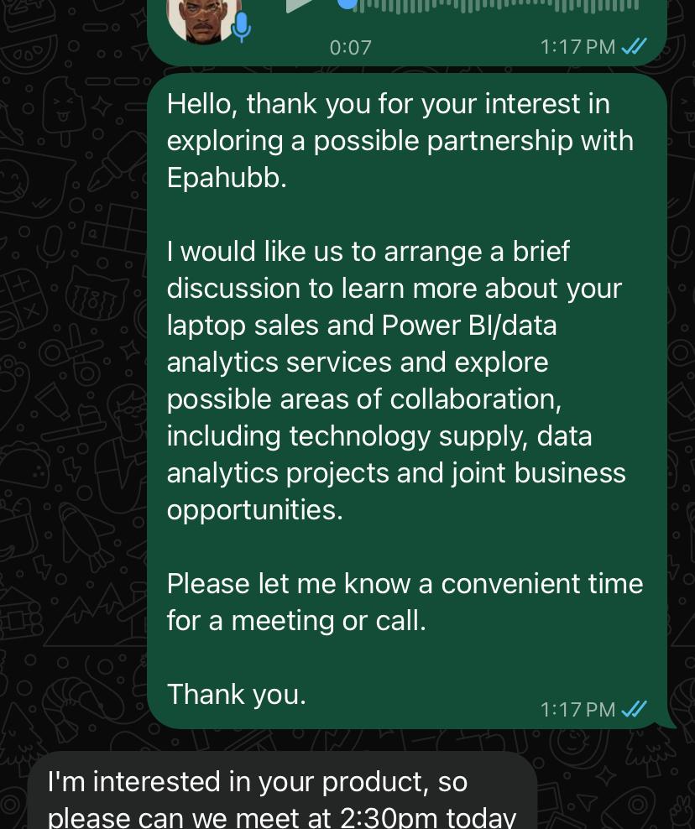

Evidence 4 – Organization 4
Organization: Marthin Luther Complex
Contact person: Headmaster
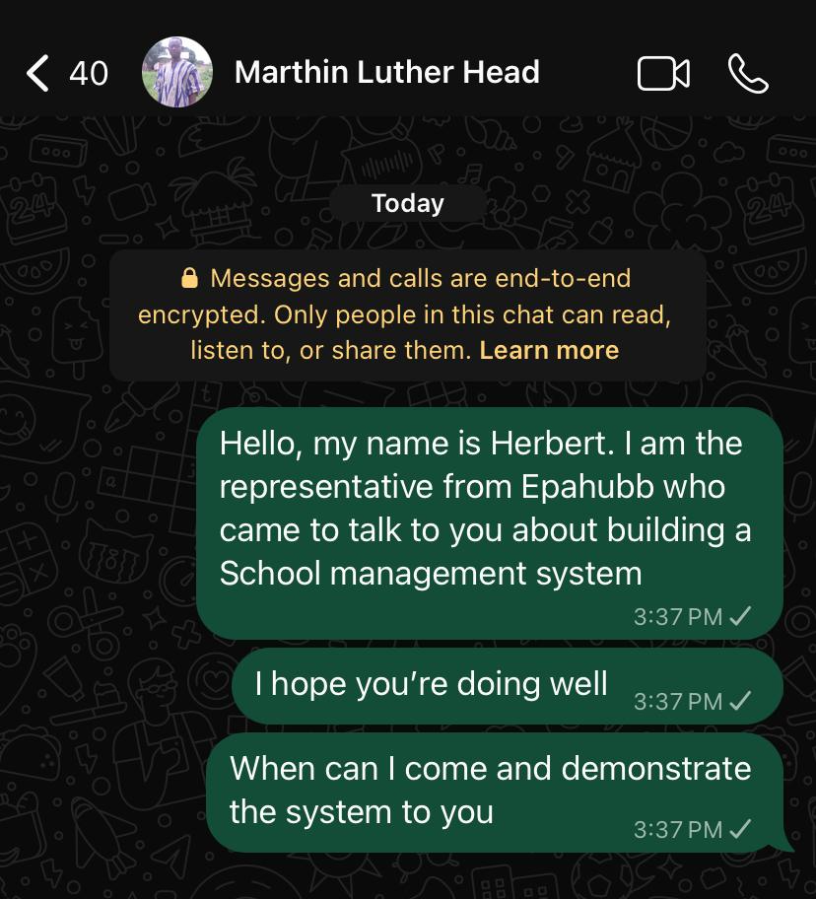

Evidence 5 – Organization 5
Organization: Next level beauty parlour
Contact person: Owner
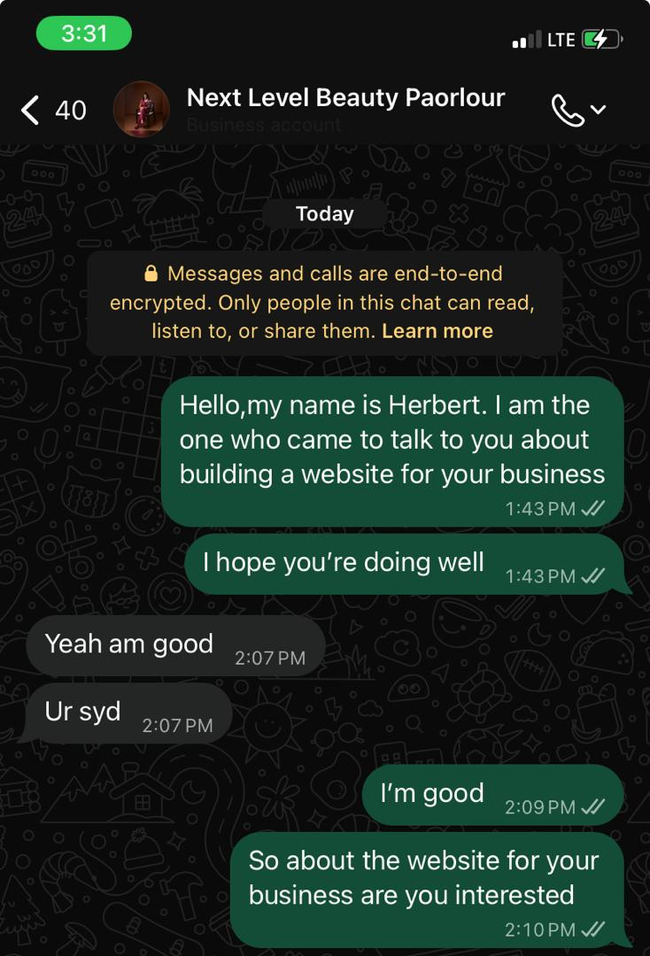

Evidence 6 – Organization 6
Organization: Anagen haircare
Contact person: Owner
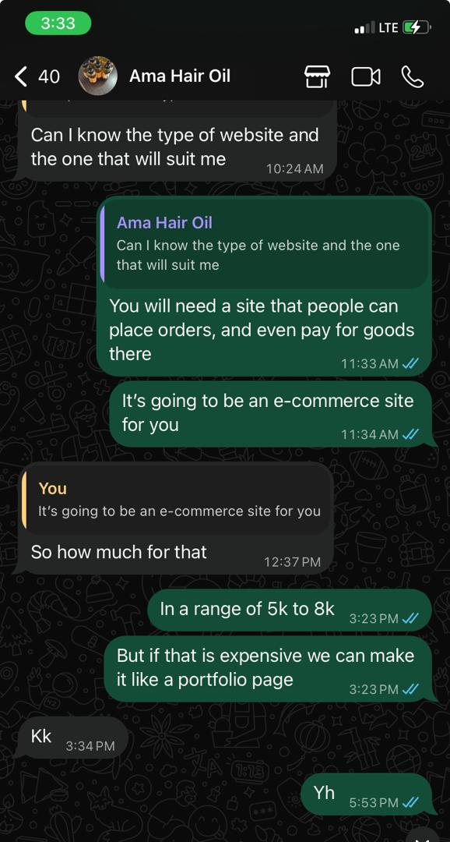

Evidence 7 – Organization 7
Organization: Boyos bite
Contact person: owner

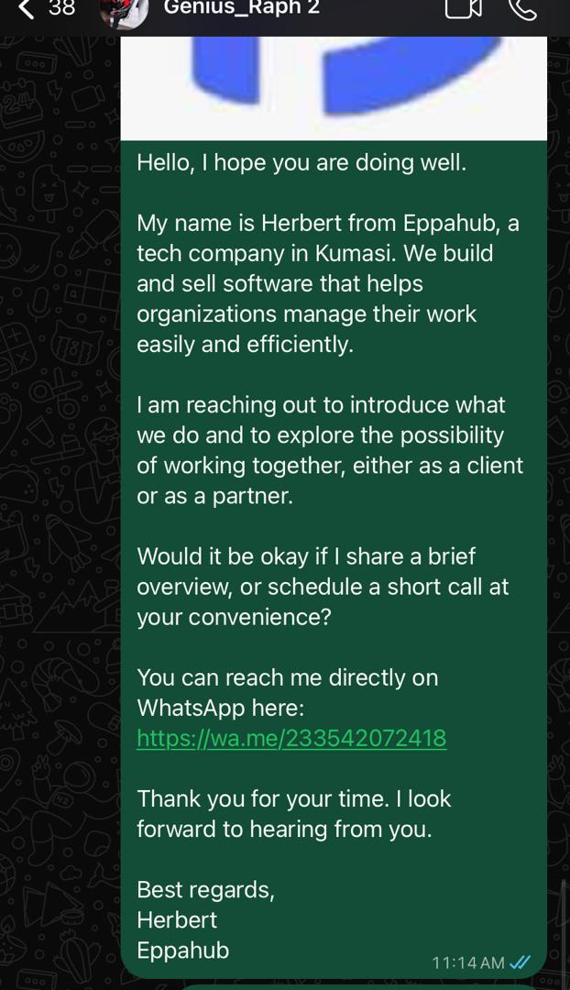

Evidence 8 – Organization 8
Organization: Solo barbering shop
Contact person: Owner

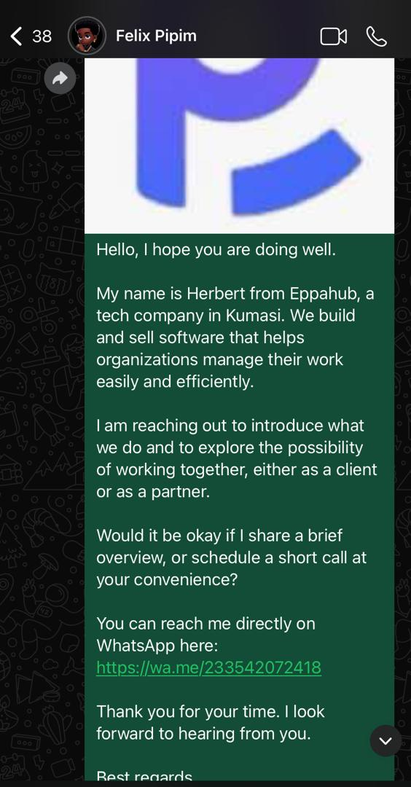

Evidence 9 – Organization 9
Organization: Auduluxe enterprise
Contact person: owner
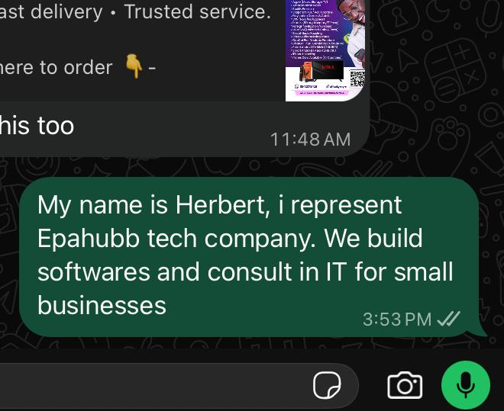

Evidence 10 – Organization 10
Organization: G’S sip and bite
Contact person: owner

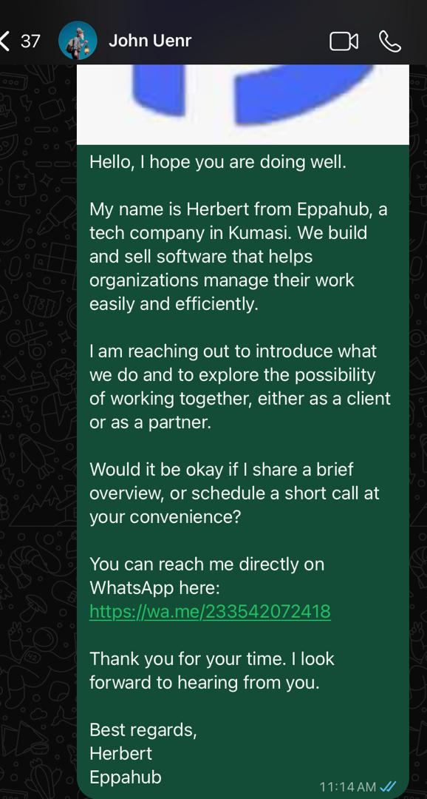

11. CONCLUSION
The outreach exercise enabled Epahubb to establish contact with 40 organizations across different business sectors and identify several potential commercial and partnership opportunities.
The most promising opportunities are within the education sector, particularly schools that have expressed interest in Epasmart or identified challenges with their current administrative systems. The potential collaboration with Frimpong Laundry also presents an opportunity to explore strategic business relationships.
The next stage will focus on confirming proposed appointments, conducting product demonstrations, gathering detailed requirements, preparing quotations and negotiating with qualified prospects.
The outreach exercise has established a prospect pipeline for Project 50K. Continued follow-up and effective conversion of the identified opportunities will be necessary to translate these engagements into actual revenue.

